EcoWatts – Smart Home Energy Analyzer
By
Aniket Atmaram Dombale

Submitted in partial fulfilment of
BSC in Data Science
Under
Savitribai Phule Pune University
For the academic year
2025-2026

Under The Guidance of
Prof. Sushrut Sir

Department of Technology,
Savitribai Phule Pune University,
Ganeshkhind, Pune 41107



CERTIFICATE
This is to certify that
Aniket A. Dombale
has successfully completed their project on
EcoWatts – Smart Home Energy Analyzer
In partial fulfilment of
BSC in Data Science
Under
Department of Technology,
Savitribai Phule Pune University,
For the academic year2025-2026

Dr. Manisha Bharti Dr. Aditya Abhyankar
(course coordinator) (H. O. D)

Prof. Sushrut Sir Signed By
(Project Guide) (External Examiner)
DECLARATION

I undersigned Aniket A. Dombale, the student of BSc in Data Science, Department of Technology, Savitribai Phule Pune University, declare that the research project titled “EcoWatts – Smart Home Energy Analyzer” is a result of my own work and my indebtedness to other work publications, references, if any, have been duly acknowledged.
If I am found guilty of copying any other report or published information and showing it as my original work, I shall be liable and punishable by the Institute or University, which may include failure in examination, repeat study, and re-submission of the report or any other punishment that the Institute or University may decide.

Aniket A. Dombale
(BSC23DS33)

Signature:

ACKNOWLEDGEMENT

We would like to extend our sincere appreciation to each and every individual and the Department of Technology who played pivotal roles in the successful completion of this project.First and foremost, I am deeply grateful to my project guide Prof. Sushrut Sir for their exceptional guidance and mentorship, which significantly enriched the project's depth and direction. I am also very thankful for the timely guidance and motivation provided by Dr. Manisha Bharti ma’am the Course coordinator of the Department of Technology.

To my peers, collaborators, and the open-source community, I express heartfelt gratitude for your contributions, insightful discussions, and assistance in fostering a productive and supportive research environment. I appreciate the efforts of all those involved in data collection and sharing, as well as the reviewers and anyone engaged with the project, offering valuable feedback and insights.

Finally, my thanks to the readers and users who will benefit from the findings presented herein. Your collective support, expertise, and encouragement were truly invaluable throughout this journey. I am also thankful to Dr. Aditya Abhyankar Sir for his continuous guidance and motivation for the project. Last but not least, I would like to thank each and every individual who directly or indirectly contributed to the successful completion of this work.

Table of contents

1. | 1. Introduction  1.1 Overview  1.2 Problem Statement  1.3 Objectives | 7
2. | 2. Dataset  2.1 Dataset Description  2.2 Features/Attributes Used | 8
3. | 3. Methodology  3.1 Data Collection  3.2 Data Preprocessing  3.3 Feature Engineering | 9
4.  5. | 4. Implementation  4.1 Python Libraries Used  4.2 Dashboard Components  4.3 Model Building (Linear Regression Forecasting)  4.4 Visualization Techniques  5. Evaluation  5.1 Model Evaluation Metrics (MAE, R² Score)  5.2 Dashboard Output & Charts  5.3 Interpretation of Results | 10
6. | 6. Sustainability Insights  6.1 Carbon Footprint Calculation  6.2 Smart Alerts  6.3 Eco-Friendly Recommendations | 12
7. | Future Scope | 13
8. | Conclusion | 13
9. | References | 14

1. Introduction
1 Overview
EcoWatts is a smart energy monitoring system built using Python and Streamlit.
It analyzes household energy usage data collected from sensors, smart meters, or pre-recorded datasets. The system provides:
- Appliance-wise and room-wise energy consumption
- Daily, weekly, and monthly cost trends
- Smart alerts for abnormal usage
- Carbon emission tracking
- Future energy consumption prediction using Linear Regression
- Eco-friendly recommendations
The project offers an intuitive dashboard that makes energy insights understandable for both technical and non-technical users.

2. Problem Statement
Modern households often struggle with:
- Lack of clarity on which appliances consume the most energy
- Unexpected electricity bill spikes
- Inefficient usage patterns and wastage
- No forecasting mechanism to plan monthly energy budgets
- No system to estimate carbon emissions from electricity consumption

3. Objectives
The main objective of this project is to analyze and visualize household electricity usage in a simple dashboard.
EcoWatts aims to show appliance-wise, room-wise, and daily usage trends to help users understand their energy consumption.
Another objective is to calculate energy cost and detect unusual high usages.
2.Datasets

The dataset used in this project contains household electricity usage records collected from smart home appliances. It includes fields such as Timestamp, Appliance Name, Room, Usage in kWh, Temperature, Mode, and Cost in INR. The dataset has around 200 records, giving a clear picture of daily energy consumption patterns. This data is used for visualization, cost analysis, and forecasting. Overall, the dataset provides sufficient information to understand home energy behavior and build the EcoWatts dashboard.

3. Methodology

1.Data Collection:
The dataset for this project was collected from smart home appliance logs and simulated IoT-based usage records. It includes details such as timestamp, appliance name, room, energy usage in kWh, temperature, and cost. The data represents real-life household electricity consumption patterns over a period of days.

2. Data Preprocessing:
The collected data is cleaned by handling missing values, formatting timestamps, and standardizing column names. Usage values are grouped by appliance, room, and date to generate meaningful insights. Duplicate records are removed, and data types are converted for accurate analysis.

3. Feature Engineering:
New features are created to enhance the analysis, such as daily usage totals, temperature-based patterns, and carbon footprint. Time-based features like day, hour, and date are extracted for better visualization and forecasting. Aggregated fields like appliance-wise and room-wise consumption help in understanding usage distribution

4.Implementation

1.python libraries:
This project uses Python as the primary programming language along with several essential libraries. Pandas and NumPy are used for data cleaning, manipulation, and preprocessing. Matplotlib, Seaborn, and Plotly are used to create interactive and clear visualizations in the dashboard.
2.Dashboard Components:
The dashboard is developed using Streamlit, which provides an interactive and user-friendly interface.It includes sections for overview, filters, visualizations, forecasting, and sustainability insights.Users can filter by appliance, room, or date to analyze specific parts of the dataset.The dashboard also displays smart alerts, eco-tips, and carbon footprint metrics.

3.Model Building:
A Linear Regression model is used to predict future energy usage based on past daily consumption. The model is trained using the cleaned and aggregated dataset, where date is converted into numerical values. Once trained, the model forecasts upcoming days’ energy usage to help users plan ahead.

4. Visualization Techniques:
The project uses Matplotlib and Seaborn for static charts and Plotly for interactive visualizations.
Key charts include appliance-wise usage, room-wise usage, daily cost trends, and forecast graphs.
Bar charts, line charts, and scatter plots are used to represent different insights effectively.

5. Evaluation
1.Model Evaluation Metrics (MAE, R² Score):
The performance of the EcoWatts system is evaluated using both visualization quality and model accuracy. The Linear Regression model is assessed using Mean Absolute Error (MAE) and R² Score, which show how closely the predictions match actual energy usage. The dashboard is also evaluated based on usability, clarity of charts, and responsiveness to filters.

2. Dashboard Output & Charts:

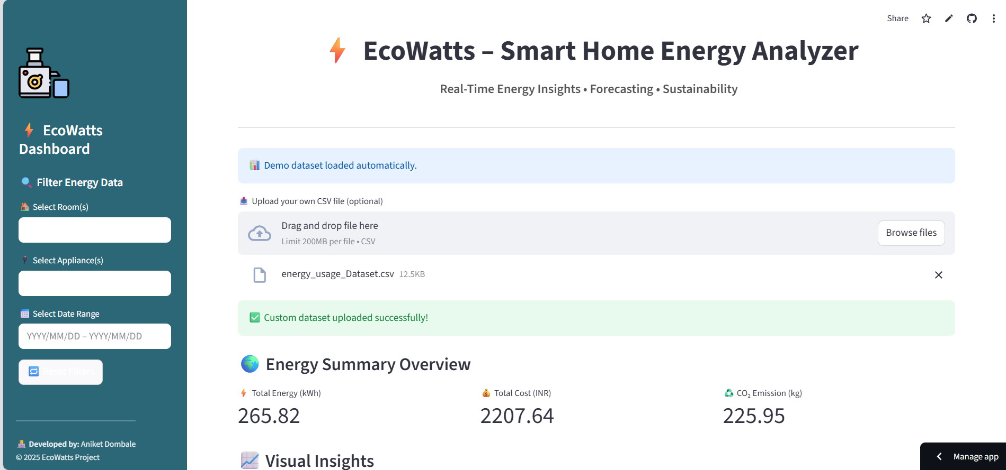

Overall, the system performs well in analyzing patterns, forecasting usage, and providing actionable insights to users.

6. Sustainability Insights

1.Carbon Footprint Calculation:
The system calculates carbon emissions based on energy usage by applying a fixed emission factor (0.85 kg CO₂ per kWh).This helps users understand the environmental impact of their electricity consumption. Appliance-wise CO₂ charts show which devices contribute most to carbon emissions.

2. Smart Alerts:
EcoWatts includes a smart alert system that detects unusual or high energy usage. If the current day’s consumption is significantly higher than the average, a warning message is displayed. This helps users identify faulty appliances or unnecessary energy wastage.
Smart alerts ensure timely action and better control over electricity usage

3. Eco-Friendly Recommendations:
The system provides simple, customized energy-saving tips based on usage patterns. These include suggestions like reducing appliance usage, switching to LEDs, and unplugging idle devices. Recommendations help reduce both electricity bills and carbon footprint. This feature makes the dashboard more helpful by encouraging sustainable and eco-friendly habits.

7.Future Scope

In the future, EcoWatts can be enhanced by integrating real-time IoT sensors for live energy monitoring. More advanced machine learning models like LSTM can be added for highly accurate long-term forecasting. A mobile app version can be developed to provide instant alerts and energy insights on the go.
The system can also include automatic appliance control to reduce wastage.
Overall, EcoWatts has strong potential to become a complete smart home energy management solution.

8. Conclusion

The EcoWatts – Smart Home Energy Analyzer successfully provides a clear and user-friendly way to monitor household electricity usage. Through interactive visualizations, forecasting, and sustainability insights, users can understand their energy patterns and reduce wastage. The system also helps in cost planning by showing daily consumption trends and predicting future usage.
Overall, EcoWatts supports smarter energy decisions, lowers electricity bills, and promotes environmentally responsible behavior.

9. References

1. “Energy Consumption Analysis and Smart Meter Data,” IEEE Research Publications.
2. “Machine Learning for Energy Forecasting,” Journal of Data Science and AI.
3. Official Pandas Documentation – https://pandas.pydata.org
4. Scikit-learn Documentation – https://scikit-learn.org
5. Streamlit Framework Documentation – https://streamlit.io
6. Various open-source articles and tutorials on energy analytics and home automation.

